**AMWG ACTION ITEMS:**

1. If you are interested in contributing to a particular diagnostic or topic in the draft MS, please add your name to the appropriate section, below (under “Working Groups”). This is not intended to be a final list (I’ve just copied the TOC from Jim’s draft), and I’m guessing that further discussion is needed to arrive at an outline that we all agree is adequate. With that in mind, please add any specific diagnostics that you think are missing, or suggestions regarding the general structure.
2. Please review the proposed structure for the “Diagnostic Template” (below) and provide comments in suggestion mode.

# Working Groups

## Model convergence and eigenvalue analysis of covariance matrix [name1, name2, ...]

Alternative initial parameter values [Jon, Kelli, …]

[Link to draft document](https://docs.google.com/document/d/1ioD1vu871VEhmRCoLVNqvGvox8A_GpvUGQNpfSw9E0Y/edit#)

## Goodness-of-fit [E.J., Peter, ...]

[Link to draft document](https://docs.google.com/document/d/1rcz4spwqid-AQFmU0DfRukU6WQNCeQ9upIAGvGrA0lo/edit#)

## Sensitivity analyses

[Link to draft document](https://docs.google.com/document/d/16ZWNwczl6EVAK62h1wpFdfJCUjBtAh2NUfnzxw6_wWE/edit#)

Basic robustness to assumptions (e.g. estimability/identifiability of parameters) [Peter, Ian, Jon]

~~Likelihood profiles [Kyle, Skyler, Dan,...] --~~ NOTE: moved this up to Goodness of fit section

Age-structured production model [Felipe, name2, …]

Retrospective analysis [Kelli, Kiersten, Dan Hennen, Dana …]

## Other practices

MCMC and Bayesian integration (wrapping this into relevant above topics) [Jon, E.J., Kelli, …]

Parametric bootstrap analysis [Skyler, Ian, …]

Cross-validation skill testing [Jon,...]

Jack-knife analysis [Skyler, …]

Empirical analyses [Kiersten…]

# Diagnostic Template

**Name**: Age-structured Production Model (ASPM)

**Goal**: The ASPM diagnostic is used to determine whether the impact of the catch on the index of abundance is driving the estimates of absolute abundance or ?, and if information on recruitment variation is needed to extract the absolute abundance information

**Description:** Contemporary fisheries stock assessments often use multiple diverse data sets to extract as much information as possible about biological and fishery processes. The ASPM diagnostics are used to illustrate if the “correct” trends in abundance (as represented by the CPUE-based relative index of abundance) can be explained by catch alone. When catch does explain indices with good contrast (e.g. declining and increasing trends), it suggests that a production function is apparent in the data, therefore providing evidence that the index is a reasonable proxy of stock trend. [If the diagnostic depends on estimation framework, then describe how this diagnostic is applied in a frequentist (joint likelihood), Bayesian (priors and joint likelihood), or random effects (penalized joint likelihood). In this case, there is no clear dependence of ASPM on the estimation framework being used to estimate model parameters.]

**How to:** To compute the ASPM diagnostic the following steps are necessary: (i) run the integrated assessment model; (ii) fix the selectivity parameters at the maximum likelihood estimates (MLEs) from the integrated assessment model, (iii) turn off estimation of all parameters except R0 and the parameters representing the initial conditions (e.g., recruitment offset for the first time step of the model and initial fishing mortality parameters), iv) set the recruitment (and the initial age structure) deviates to zero (adjusting the bias-correction factor appropriately), and (v) fit the model to the indices of abundance only. Trends in relative spawning stock size can then be compared between the full integrated stock assessment model and the ASPM.

**What to do:**

**Example:**

The example presented here is based on the stock assessment for the North Atlantic shortfin mako shark using Stock Synthesis (SFM, Courtney et al., 2017). The vast majority of SFM are caught by pelagic longline operations, but due to strong spatial structuring of size classes, the selectivity pattern differs among the fishing fleets operating in the different regions (Courtney et al., 2017). The SFM example represents a length-based age- and sex-structured multi-fleet model that is fit to six standardized CPUE indices. Fisheries-dependent size composition data are assumed to be representative of the different selectivity patterns for the six major surface longline fishing fleets.

The ASPM example results are provided in **Figure x**. Both the fully integrated and the ASPM models showed similar overall trend in Spawning Stock Biomass, however after the 1990’s the ASPM showed a less steep decline in SSB than the full integrated stock assessment model. The asymptotic 95% confidence intervals of SSB size did not overlap for many of the most recent years.

The differences observed here between the full integrated stock assessment model compared to the ASPM are explained by the estimated recruitment deviations in the full model (**Figure x**), which allowed for variability in age-0 recruitment. In contrast, the ASPM fixed recruitment to the assumed stock recruitment curve which limited inter-annual variability in age-0 recruitment and resulted in a relatively poor fit to the observed trends CPUE (**Figure x**).

**Recommendations:** In the past decade fisheries assessment modelling has moved to use of multiple data types to inform modelled processes. The ASPM plays the vital role of simply measuring the effects of fishing using the relationship between catch and abundance. This diagnostic can be an important step before building a more complicated assessment model.

**Key Literature:**

Minte-Vera, C., Maunder, M.N., Aires-da-Silva, A.M., Satoh, K., Uosaki, K., 2017. Get the biology right or use size-composition data at your own peril. Fish. Res. 192,114–125.

Maunder, M.N., Piner, K.R., 2015. Contemporary fisheries stock assessment: many issues still remain. ICES J. Mar. Sci. 72, 7–18, <http://dx.doi.org/10.1093/icesjms/fsu015>.

Maunder, M.N., Piner, K.R., 2017. Dealing with data conflicts in statistical inference of population assessment models that integrate information from multiple diverse data sets. Fish. Res. 192, 16–27.

[Include references to specific assessments]

[When MS is complete, include links to SS examples in online (“living”) version, perhaps hosted on Vlab or an internet location that is regularly maintained.]

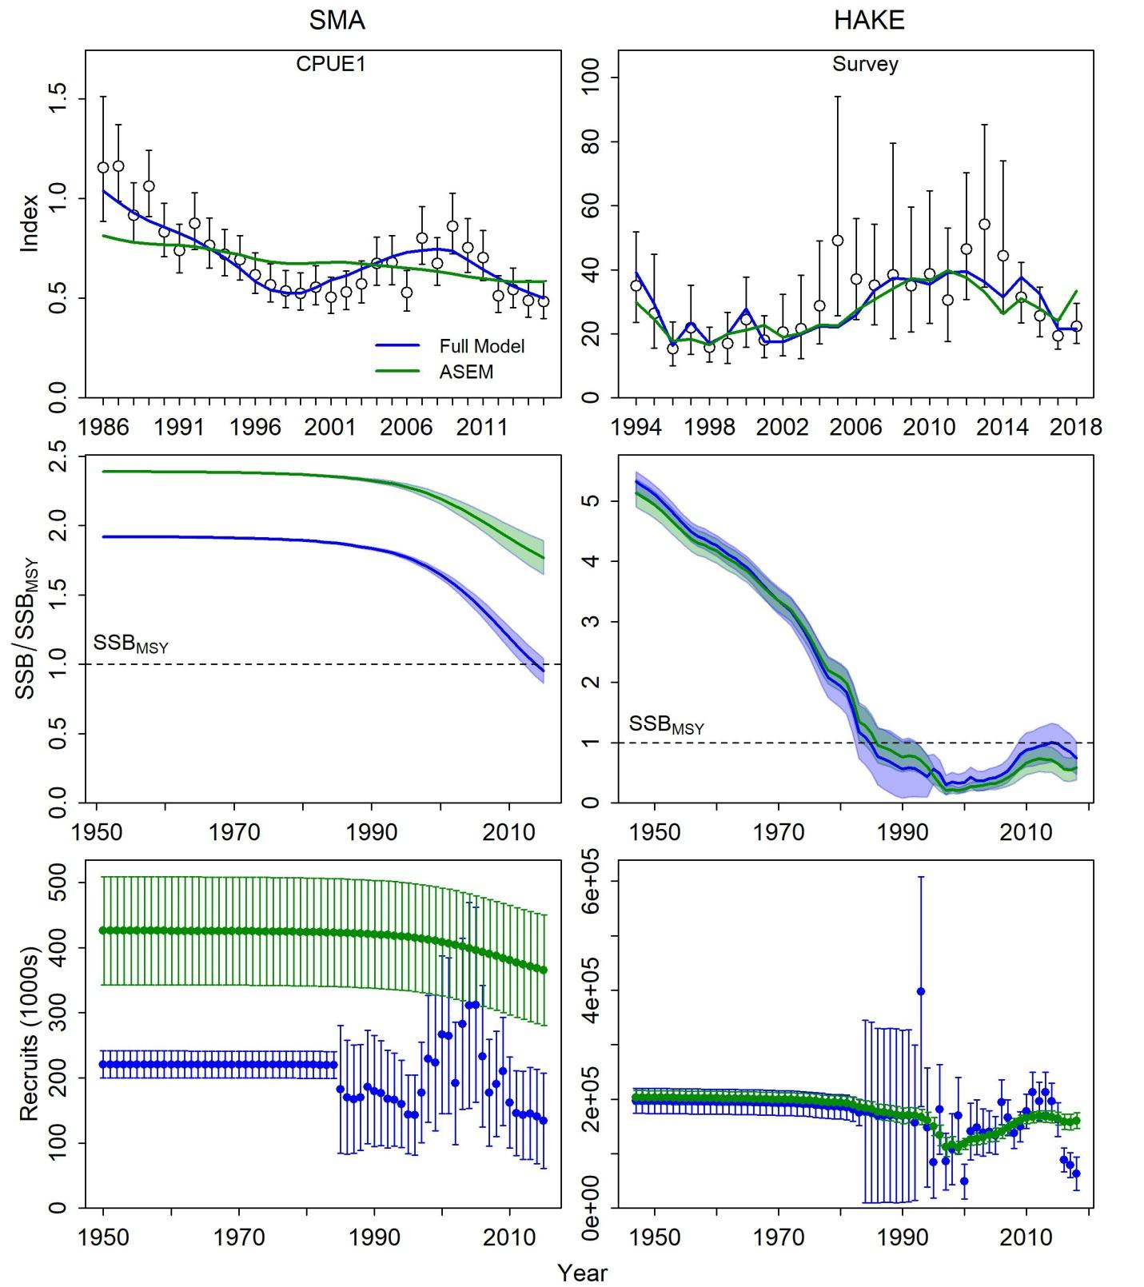

Figure x